Running Bitcoin Core on the Command Line (Part 2): Wallets
You know the adage “not my keys, not my bitcoin?” Well, I set out to see what it took to get in control of my own keys. The path is non-trivial, and fraught with risks, such as losing addresses and the keys associated with them. I believe that the only thing standing between Bitcoin and a much greater market cap is not some ideological war, but a practical hurdle: Bitcoin is too difficult to deal with, it is by no means accessible. People are afraid of total loss, and with good reason. Stories like the man who lost $127M worth of bitcoins haunt our consciousness, while personally, it would really hurt to lose even a couple thousand. Cryptocurrency exchanges with better customer service, and user-friendly wallets may deliver us yet, but there is still a long way to go. While there are many people working to bring down the barriers to entry, I figured I would do my part to show you what goes on under the hood of “traditional” bitcoin. Read on as we go inside the Bitcoin Core.
In part 1 of this article, I explained how I got a Bitcoin Core full node running on an Ubuntu 18.04 LTS Linux PC. If you don’t already have a full node set up, click the link and do that first. Next, I will explain the basics of how to manage your wallet and transact using bitcoin-cli and the command line.
Disclaimer: I am 100% not responsible for theft or loss of your coins if you follow this guide. It is only for informational purposes. Please always use small amounts of bitcoin to test and develop your skills before moving any significant portion of your holdings.
Create a Wallet
All you need to do to create a wallet:
$ bitcoin-cli createwallet "lockbox"
Encrypt it for protection:
$ bitcoin-cli -rpcwallet="lockbox" encryptwallet "my_password"
You can now retrieve info about the wallet using getwalletinfo:
bitcoin-cli -rpcwallet="lockbox" getwalletinfo
Create an Address
$ bitcoin-cli -rpcwallet="lockbox" getnewaddress "primary"
After creating your address, it will spit it back to you as output. Copy and save it. We also gave it a label “primary,” which is highly recommended so that you can find it easily later. If you need to retrieve this address, say, if you want to receive BTC, then just do the following:
$ bitcoin-cli -rpcwallet="lockbox" getaddressesbylabel "primary"
# output:
{
"wgpkfrgq1cbnquual7mn6mwescr35j6xr0qwpqe6z68": {
"purpose": "receive"
}
}
Wallet Directory Funny Business
After creating the new wallet, you will have two wallets. One with no name “” and the one named “lockbox.” To avoid future confusion between the parent wallets of my addresses (and potentially losing my bitcoin), I decided to move the unnamed, default wallet to another directory outside of the wallets directory. I’m not going to use it. You can do this by just moving the following files:
database db.log wallet.dat
You should just have a folder for your main wallet in there now:
$ ls .bitcoin/wallets
# output:
lockbox
Note that if you have more than one wallet, for most operations, you will need to specify which wallet you are talking about by using commands of the form:
$ bitcoin-cli -rpcwallet="wallet_name" command
If you only have one wallet, or just one folder in the .bitcoin/wallets directory, then you won’t have to specify every time. This is just a convenience thing. From hereon, I will omit the -rpcwallet flag, as we will specify which wallet we want to use by default in the configuration file.
The Configuration File
So we have a dedicated wallet and at least one address. Now we just want to personalize our node a little more. Open up your bitcoin.conf file and paste in a few lines:
nano ~/.bitcoin/bitcoin.conf
# specify your default wallet
wallet=lockbox
# enables daemon in bitcoin-qt server=1
# specify max number of addresses you can have
keypool=10000
# ctrl + C; Y to save and exit
As mentioned before, now bitcoin-cli knows what wallet we are using by default, and don’t have to specify it with -rpcwallet flag.
If you want to use the GUI for your wallet, we enable that here, too, by adding the server=1 setting. Then, if you fire up the GUI using bitcoin-qt it will give also get your Bitcoin node running.
The keypool setting is a safety measure. As we will see in the following section, because of the use of “change addresses” in the Bitcoin protocol, we need to have a high number of reserve addresses to send BTC to. The keypool setting sets the upper limit for the number of addresses we may have in the wallet. This will prevent us from diverting change to an address no longer in our wallet, and therefore losing our Bitcoin by misplacing this address. If this is not obvious what I am talking about, don’t worry, but please read on to understand how change addresses work.
Before we proceed, though, stop and restart your node for the changes to your bitcoin.conf file to take effect:
$ bitcoin-cli stop
# stops bitcoin core
$ bitcoind -daemon
# start bitcoin core
Change Addresses
Perhaps most surprising, and challenging to new users, is the idea of change addresses. The first time a Bitcoin user sends to an address, then checks the blockchain for their transaction, they are alarmed to see that the entire contents of their sending address was emptied, and the intended amount was sent to the recipient correctly, but the remaining balance is going to an address they don’t recognize! This could be a serious deterrent to any would-be user. Don’t worry, this is the correct behavior.
What is going on is that, as a practical solution, and a privacy feature, the wallet is “making change.” First, how change works. The easiest way to think about what’s happening is that when you go to the gas station and pay for a candy bar, but you only have a $20 bill, you will give them the twenty and receive back a $10, $5, 3x $1’s, and maybe 3x quarters. Same thing here. When you send Bitcoin, the receiver first takes the larger amount, subtracts their portion from it, and then returns the rest to you, via the newly created change account. In this description of how change works, they describe each transaction as having a set of inputs and outputs. In our case, the $20 bill is the input, while the $1.25 for the candy bar, and the $18.75 in change are the outputs. Note that each output can then become the input for a subsequent transaction. And the formation of the new account serves a couple purposes, but to my understanding also prevents double-spending, or refuting that an address never sent/received the Bitcoin associated with a particular transaction. And now we see why we set the keypool limit so high. If you are using your wallet with regularity, there will be a very large number of addresses generated, and we want to prevent the change from being sent to an address outside your wallet. If this does happen, it is possible that a backup of your wallet may not contain the address and related keys, and may forever be lost if you are unaware of where it went.
On to the privacy piece: if every user was to just send the bitcoin to a single address, then it would create a fairly clear chain of transactions to follow back. Now, if every transaction has two recipients, it may be easy to discern who the intended recipient is from a small set of transactions, but the number of total transactions rapidly grows. The persistent doubling creates a web that becomes computationally very expensive (2^n) to go back and comb through. This obfuscation through complexity is a clever deterrent to any organized user who would try to monitor the web of transactions en-masse. I am sure it could be done, this just makes it a bit harder.
Receiving Bitcoin
To receive, it’s pretty straightforward: just point and shoot. Previously, we created the address with the “primary” tag in order to receive Bitcoin. So, say you bought some BTC off of an exchange, and you don’t trust them to keep it safe, just send to your new address. Let’s do that:
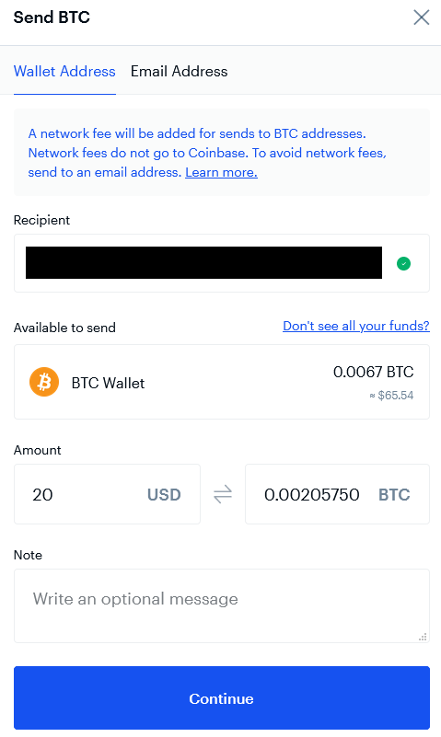Image 1: sending a $20 bill from an exchange to our new address.
Side note: don’t make fun of me for having a Coinbase account. I had the account before there were many options. I also cannot endorse them at this time: their customer service is truly atrocious.
After sending, it may take a half hour or more to receive, depending on network traffic. To confirm receipt, you can check your wallet balance:
$ bitcoin-cli getbalance
# output:
0.00205825
Beware that if your Bitcoin node is not fully synced, it may take much longer, for the balance to read correctly. If the node is not syncing at all, then the balance will never show correctly. Go back and read part 1 of this guide if you need to check your node’s status.
Sending Bitcoin
To send Bitcoin you will first need to unlock the wallet:
$ bitcoin-cli walletpassphrase "my_password" 60
The command above unlocks your wallet for 60 seconds. So prepare your send command beforehand, and then unlock the wallet. Immediately following, paste to send:
$ bitcoin-cli sendtoaddress "receiving_address" 0.0005
After sending, you will have a long string of characters that is the hash code for the transaction. You can then go to the blockchain to monitor that transaction:
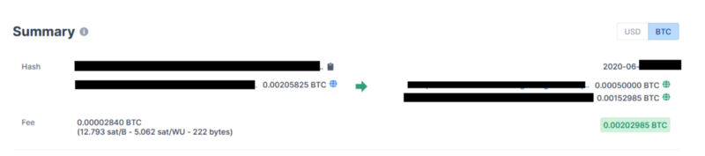Image 2: transaction details using Blockchain Explorer.
Note that from the image above, you can see the 0.0005 BTC getting to the receiving address correctly, and the change from the sender address being diverted off to a new address.
Address Balances
One thing that I found sort of troubling is that neither applications for Bitcoin Core (bitcoin-cli, bitcoin-qt) have a means of telling you the balance within a particular address. However, with the rampant proliferation of addresses within a given wallet, it doesn’t really make sense to try to keep track of the contents of the addresses themselves. In the transaction above I had just created a new address and sent the small amount to myself. As a sanity check, I wanted to know that I was still in possession of the change:
#check my balance:
$ bitcoin-cli getbalance
# output:
0.00202985
#is that change address mine?
$ bitcoin-cli getaddressinfo "<address>" | jq .ismine
# output:
true
Getting Bitcoin Wallet Balance in Dollars
I created a simple script to retrieve the BTC/USD conversion rate, multiply by the wallet balance (in BTC), to get the current wallet value in dollars. Feel free to copy/paste and use yourself:
$ nano ~/local/get_wallet_balance
### paste this script
#!/bin/bash price_str=`curl -s --request GET --url 'https://api.coindesk.com/v1/bpi/currentprice/USD.json' | jq .bpi.USD.rate | tr -d "," | tr -d '"'` date_str=` date '+%Y-%m-%d %T'` echo "" wallet_name="lockbox" #btc_str=`bitcoin-cli -rpcwallet=${wallet_name} getbalance` btc_str=`bitcoin-cli getbalance` usd_balance=`echo "scale=2; (${btc_str}*${price_str})/1.00" | bc -l` echo "date: $date_str" echo "your wallet name: $wallet_name" echo "your wallet bitcoin balance: $btc_str" echo "current USD/BTC rate: $price_str" echo "your wallet balance in USD: $usd_balance"
# ctrl + C; Y to save and exit
Get the script ready to use:
chmod +x ~/local/get_wallet_balance
And if you haven’t already, add your local script directory to your path:
$ echo “export PATH=$PATH:/home/username/local” >> ~/.bashrc
And reload your bash profile to make the command work:
$ source ~/.bashrc
Great! Now see it in action:
$ get_wallet_balance
# output:
date: 2020-06-13 11:32:30 your wallet name: lockbox your wallet bitcoin balance: 0.00202985 current USD/BTC rate: 9446.0579 your wallet balance in USD: 19.17
Recap
I hope that this article was helpful for your to start playing around with Bitcoin Core on the command line. As we learned, change addresses can be confusing, and disquieting if you don’t know where your Bitcoin is going. While you cannot really see the contents of individual addresses from Bitcoin Core, just be sure to maintain control of the wallet and you should be okay. In future articles I will write up my tips to effectively back up your wallet, to prevent against loss. Until then, thank you for reading!

